

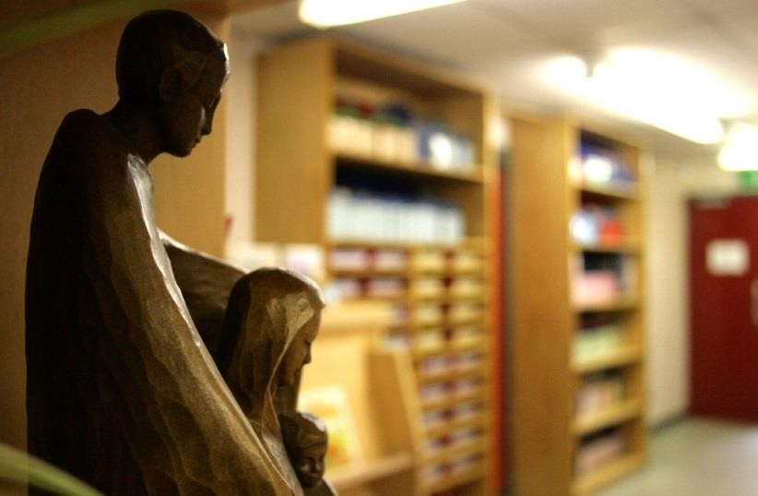

|  |  |
| --- | --- |
| **Leader/Co-ordinator** | Mr L Richardson |
| **Groups involved in discussion** | Headteacher All Staff Governing Body Pupils |

# “Worship is concerned with reverence or veneration paid to a divine being or power.” (Circular 1/94)

Collective worship at Saint Ambrose Barlow provides opportunities for pupils and staff to come together to worship God. It is rooted in the example and teachings of Jesus Christ whilst taking into account the religious and educational needs of all who share in it.

Collective Worship is an educational experience or a reflection to which all can contribute and from which all can gain.

* Those who form part of the worshipping community in church
* Those for whom school may be their first and only experience of church
* Those from other Christian traditions
* Those from other faith backgrounds

# The Aims of Collective Worship

Through our Worship together we aim to:

To reflect on spiritual and moral issues

To reflect on personal beliefs and help strengthen their individual faith. To guide the children on their faith journey.

To develop community spirit

To respond to and celebrate life To reinforce positive attitudes

To contemplate something of the mystery of God To enable and encourage a sense of belonging To encourage a common ethos and shared values To build a firm foundation for liturgy

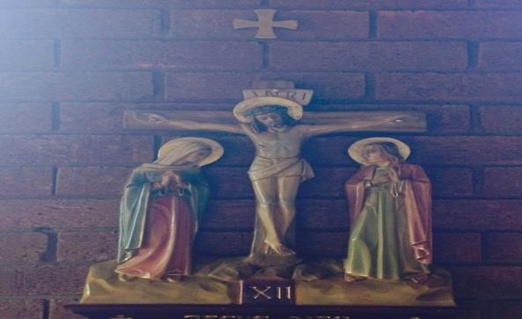To enrich the religious experience of children and staff To mark as special

To give worth to

To wonder at To take time to

To come to terms with…

# Who should be involved in Collective Worship?

Pupils – they must have the opportunity to take part in daily Collective Worship. Chaplaincy/Worship Team – they will plan and lead Key Stage Collective Worship. Teachers – they plan and enable Collective Worship to take place each day.

All staff – they are invited to participate in all acts of Collective Worship.

Parents – they too are invited to participate in acts of Collective Worship during class assemblies, meetings for Sacramental preparation, etc.

# Where should Collective Worship take place?

* In the classrooms
* In the hall
* In church
* In the open if appropriate

# When should Collective Worship take place?

Collective Worship need not occur at the beginning of the day but rather at the time that is most appropriate for us as a school to ensure that it is a meaningful and prayerful opportunity for all participants.

# How should Collective Worship be delivered?

Collective Worship can take many forms:

* Can be led by pupils, staff or visitors
* Can be offered for a class, a phase or whole school
* Should use a balance of quiet reflection, silence, prayers, responses, music, songs, dance, drama, slides, video or short address
* Should provide a focus using artefacts, candles, symbols and lighting
* Ensures the theme, focus, delivery, length and resources are appropriate to the interests, age range, backgrounds and abilities of the pupils
* Respect the freedom of pupils and staff in the invitation to prayer and worship
* Set an appropriate atmosphere with a sense of order and occasion, including entry and exit
* Ensure the possibility of conscious, active participation of all present

# How should Collective Worship be planned, recorded and evaluated? Planned

* Through/with reference to the church’s seasons, significant dates and the Come and See curriculum
* With the flexibility to respond to changing situations with the school and the wider community

# Recorded

* Through displays, prayers, photographs, etc.
* Through planning to keep note of themes, leaders, pupil groupings

# Evaluated

* By staff and pupils on a regular basis

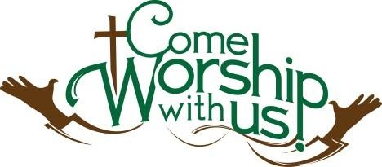

# Opportunities provided for Collective Worship Foundation Stage

Monday - Whole school Collective Worship/Classroom Based

Tuesday - Classroom Based

Wednesday - Key Stage Collective Worship/Classroom Based

Thursday - Classroom Based

Friday - Whole School Collective Worship/Classroom Based

# Key Stage One

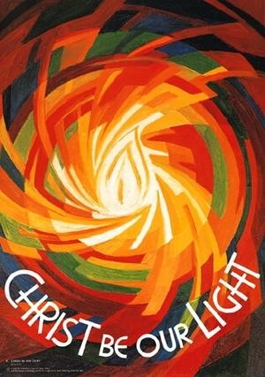

Monday - Whole school Collective Worship/Classroom Based

Tuesday - Classroom Based

Wednesday - Key Stage Collective Worship

Thursday - Classroom Based

Friday - Whole School Collective Worship/Classroom Based

# Key Stage Two

Monday - Whole school Collective Worship/Within classroom Tuesday - Classroom Based

Wednesday - Classroom Based

Thursday - Key Stage Collective Worship

Friday - Whole School Collective Worship

*Parents have the right to withdraw their child from daily collective worship*

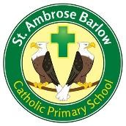Saint Ambrose Barlow Catholic Primary School

# Class Collective Worship

There will be a series of whole class collective worships throughout the year which parents will be invited.

# Whole School

Throughout the year pupils participate in Mass, and deliver seasonal services for parents and members of the community

E.g. Advent, Carol Services, Ash Wednesday, Easter Service, Corpus Christi, etc.

# Leavers

A special Mass is celebrated at the end of the academic year, which recalls the children’s journey through our school and points towards their future lives in Secondary School.

# Review

This policy will be reviewed on a yearly basis but maybe changed/updated at any time, following discussions with staff, so that it always remains a workable document.